Lab 3.1 Full Write-up: Promoting a Windows Server 2022 VM to a Domain Controller
Course: Network Defense & Countermeasures (CSCI 4647), East Tennessee State University Author: Mohamed Khalil
This is the step-by-step record of everything I did on this lab, in the order I did it, with the screenshot that backs up each step. It covers three build attempts. Attempts 1 and 2 promoted successfully but left the domain without its DNS zones. Attempt 3 worked.
How to read it: each step lists what I did, what I expected to see, and what I actually saw. Screenshot numbers match the files in images/.

Contents
- Starting point
- Attempt 1: Server Manager wizard (Sep 18)
- Troubleshooting attempt 1
- Restore and Attempt 2: PowerShell promotion (Sep 18 to 21)
- Attempt 3: the working build (Oct 5)
- What is not covered by my evidence
- Command reference

1. Starting point
I started from the VM I built in Lab 2.1: Windows Server 2022 Standard Evaluation (Desktop Experience), 2 vCPU, 4 GB RAM, 60 GB disk, in VirtualBox. It had two network adapters, a NAT adapter used for Windows Update and a host-only adapter on LAB-LAN (10.20.2.0/24, DHCP disabled), with the host-only side set to the static address 10.20.2.10. Windows Update never completed on this VM (it hung repeatedly), which I documented in my Lab 2.1 submission.
Lab 3.1 turns this server into the first domain controller of a new, isolated forest.

2. Attempt 1: Server Manager wizard (Sep 18)
Forest name used: ad.etsulab.example (the name the assignment specified).

Step 1. Remove the NAT adapter
A domain controller should be single-homed. A second adapter can make it register the wrong address in DNS, and the NAT path was only ever there for updates.
What I did: shut the VM down, turned off Adapter 1 (NAT) in VirtualBox under Settings, Network, then booted it again.
Expected: one network adapter left. Observed: Get-NetAdapter shows a single adapter, Ethernet, index 10, status Up.
Get-NetAdapter | Sort-Object ifIndex | Format-Table ifIndex, Name, Status, MacAddress
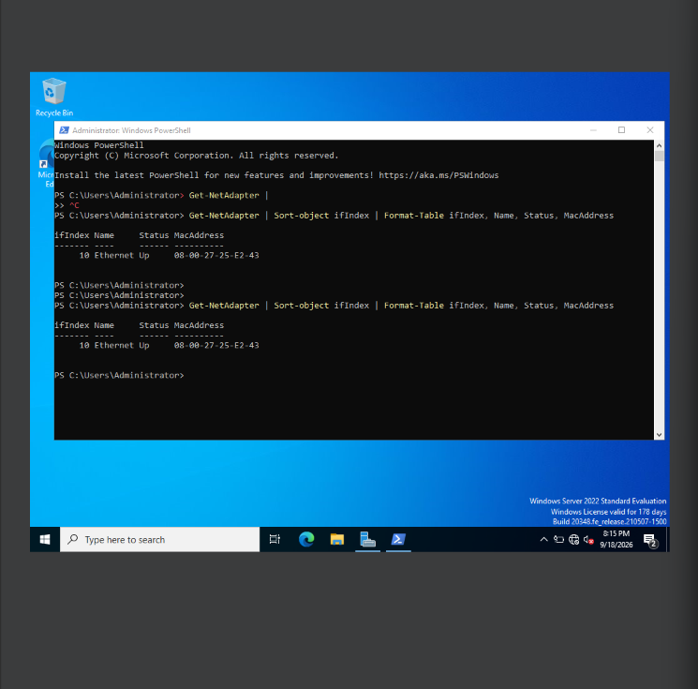

Step 2. Finalize networking and rename the server
What I did:
- Renamed the interface to LAB-LAN.
- Confirmed the static address 10.20.2.10/24 with a blank default gateway.
- Pointed DNS at the server itself (10.20.2.10), because it will host its own AD-integrated DNS.
- Renamed the computer to DC-LAB-01 and rebooted.
Set-DnsClientServerAddress -InterfaceAlias "LAB-LAN" -ServerAddresses 10.20.2.10
Rename-Computer -NewName "DC-LAB-01" -Restart

Step 3. Verify the pre-promotion state
I ran the checks below before touching AD DS, so I'd have a known-clean starting point.
hostname
Get-NetIPConfiguration
Get-DnsClientServerAddress -AddressFamily IPv4
Get-NetFirewallProfile | Select-Object Name, Enabled
Get-MpComputerStatus | Select-Object AntivirusEnabled, RealTimeProtectionEnabled
Get-WindowsFeature AD-Domain-Services,DNS,DHCP
Expected: hostname DC-LAB-01, LAB-LAN at 10.20.2.10 with no gateway, DNS pointing at itself, firewall on for all three profiles, Defender and real-time protection on, and the three roles showing Available (not installed). Observed: all of the above.
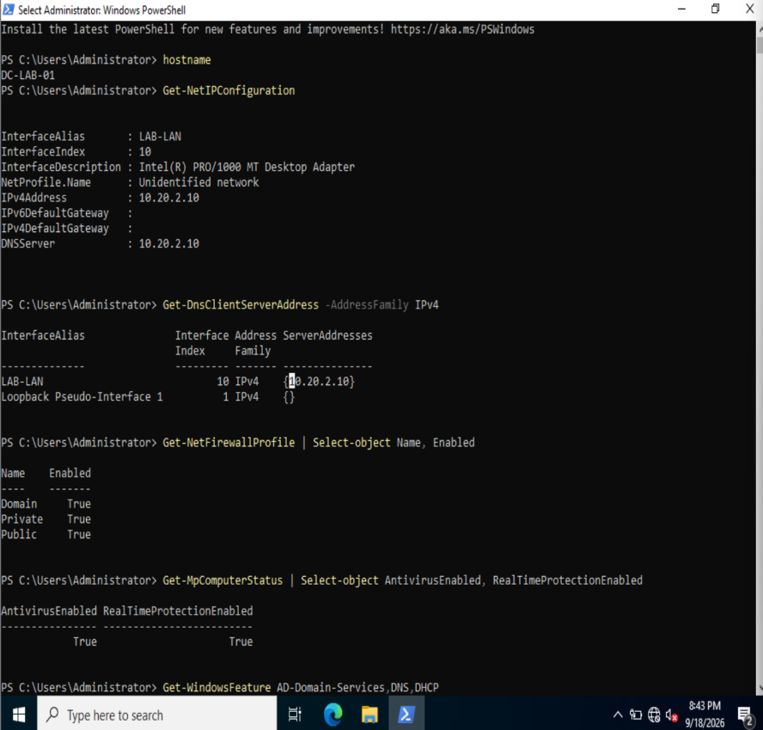
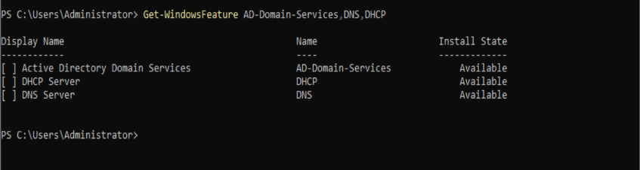

Step 4. Take the rollback snapshot
I shut the VM down cleanly and took a snapshot named 02-Pre-ADDS. It paid for itself later, because I restored it twice. The VirtualBox title bar in the next screenshot shows (02-Pre-ADDS).

Step 5. Install AD DS and promote the server
What I did, in Server Manager: Manage, Add Roles and Features, role-based installation, checked Active Directory Domain Services (with management tools), installed it, then clicked the notification flag and chose "Promote this server to a domain controller." In the wizard I chose Add a new forest, entered ad.etsulab.example, kept DNS Server and Global Catalog checked, set a lab-only DSRM password, kept the default paths, ran the prerequisite check, and clicked Install.
Expected: two non-blocking warnings (an NT 4.0 cryptography note, and a DNS delegation warning because there is no parent DNS zone), then an automatic restart. Observed: exactly those two warnings, with the installer on "Waiting for DNS installation to finish."
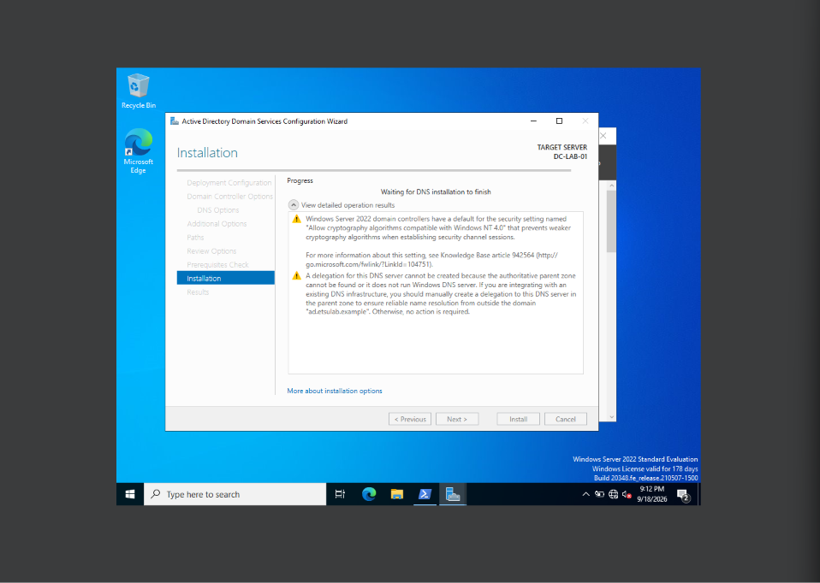

Step 6. Sign in and confirm the promotion
After the restart I signed in as the domain administrator and ran whoami.
Expected: a domain-qualified name. Observed: etsulab\administrator, so the server was now a domain controller.
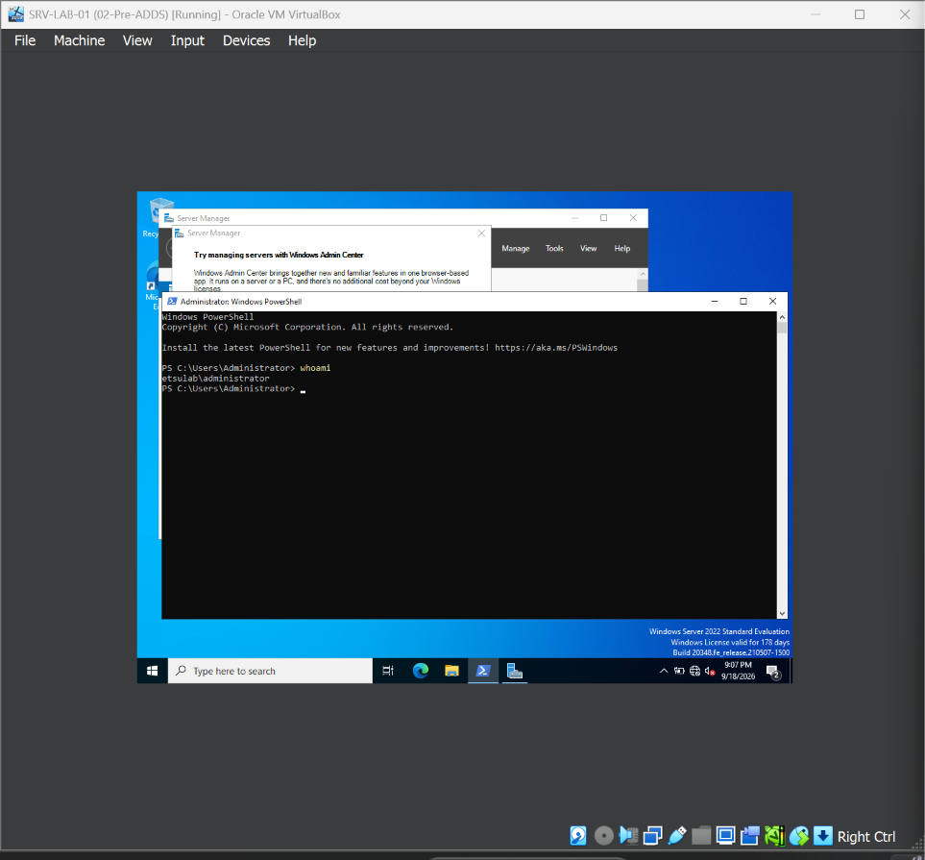

3. Troubleshooting attempt 1

Step 7. Check DNS and find the problem
I opened DNS Manager to look for the domain's zones.
Expected: forward lookup zones ad.etsulab.example and _msdcs.ad.etsulab.example. Observed: nothing listed under Forward Lookup Zones.
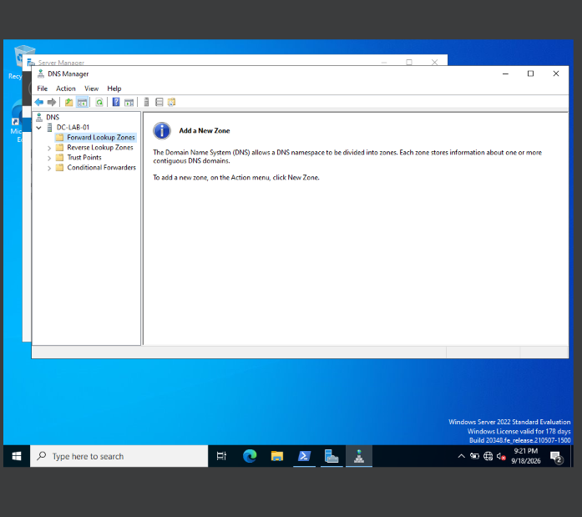
I then checked from PowerShell. The forest existed, but Get-DnsServerZone returned only the built-in reverse zones and TrustAnchors. The DNS service itself was running.
Get-ADForest | Select-Object Name, ForestMode, RootDomain
Get-DnsServerZone
Get-Service DNS
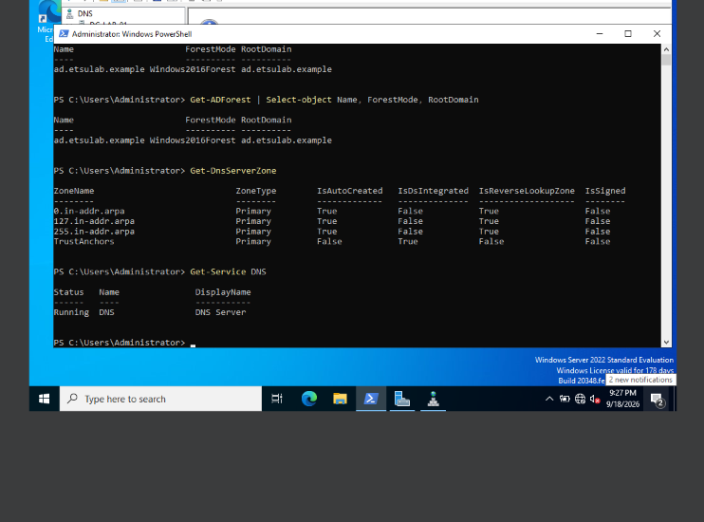

Step 8. Run DCDiag's DNS test
dcdiag /test:DNS /v
The summary reports ad.etsulab.example failed test DNS. For DC-LAB-01 the Basic and Registration tests show FAIL, and the Dynamic update test shows a warning.
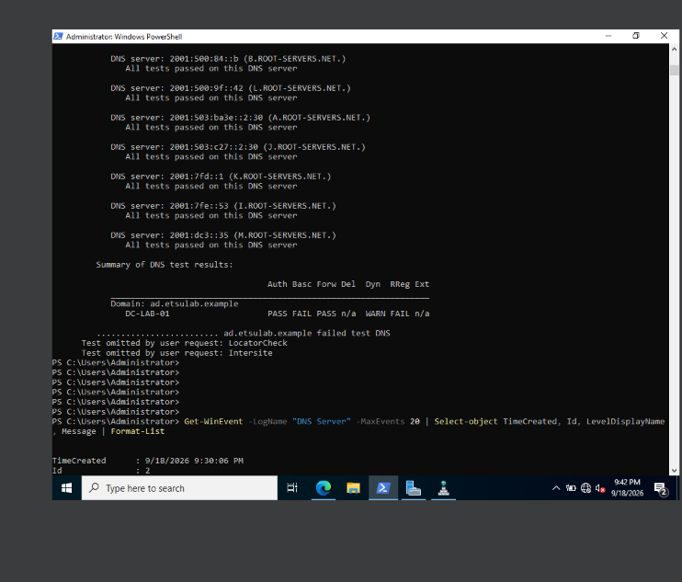

Step 9. Read the DNS Server event log
Get-WinEvent -LogName "DNS Server" -MaxEvents 20 | Select-Object TimeCreated, Id, LevelDisplayName, Message | Format-List
Event 708: the DNS server did not detect any zones during initialization, so it ran as a caching-only server.
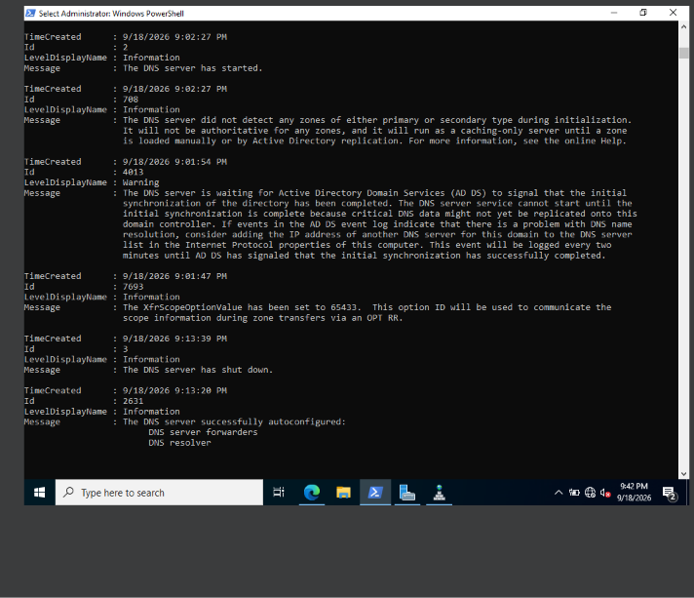
Event 4013: DNS was waiting for Active Directory Domain Services to signal that its initial synchronization had finished.
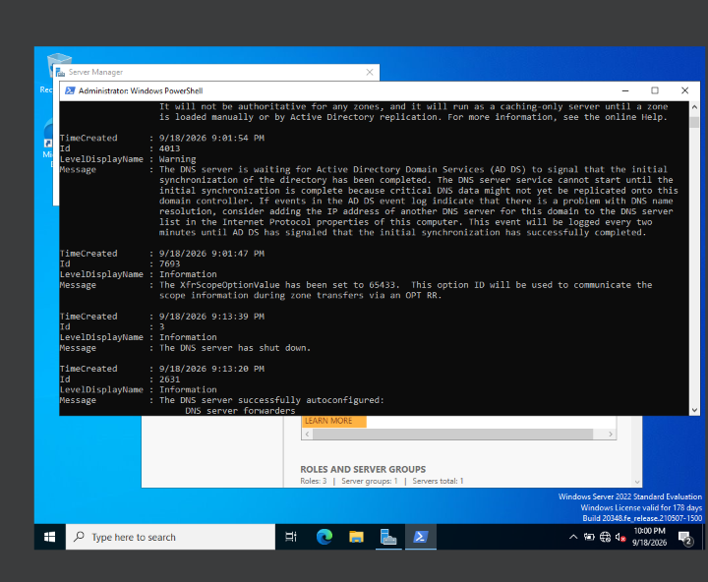
Diagnosis: DNS started before AD DS was ready, so it never loaded the zone from the directory. My working theory was a startup ordering problem made worse by a small VM (2 vCPU, 4 GB). I did not prove it.

Step 10. Try the quick fixes
What I tried, in order:
- ipconfig /registerdns, then Restart-Service DNS. The zone did not appear.
- A full VM restart. The VM hung on the restart screen for a long time. After it stayed stuck I powered it off in VirtualBox and started it again.
After the restart ADWS, DFSR, DNS, and Netlogon were all running. (The red error is my typo of KDS for the real service name Kdc.) The domain zone was still missing.
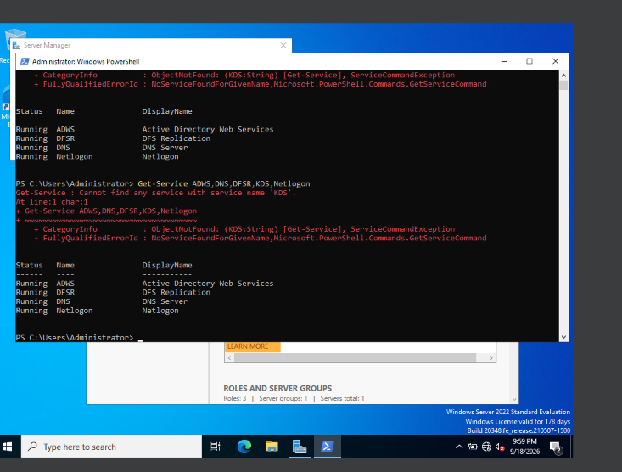

4. Restore and Attempt 2: PowerShell promotion (Sep 18 to 21)

Step 11. Restore the snapshot
I restored 02-Pre-ADDS to get back to a clean, pre-promotion state.
Expected: local administrator login, AD DS not installed. Observed: whoami returns the local ...-01\administrator account and AD DS shows Available.
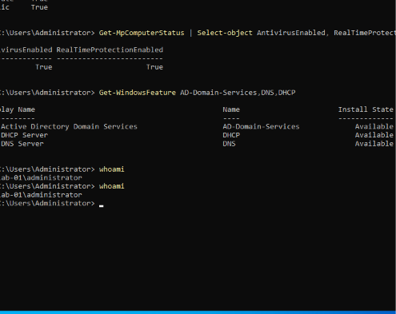

Step 12. Promote again, this time in PowerShell
Install-WindowsFeature AD-Domain-Services -IncludeManagementTools
Install-ADDSForest -DomainName "ad.etsulab.example" -InstallDNS -Force
The command above is my reconstruction. The screenshot shows the output, not the command line I typed.
Expected: the same two warnings, then an automatic restart. Observed: validation passed, "Installing new forest," and the same two warnings. The first boot after this promotion sat on "Applying computer settings" for a long time before reaching the login screen.
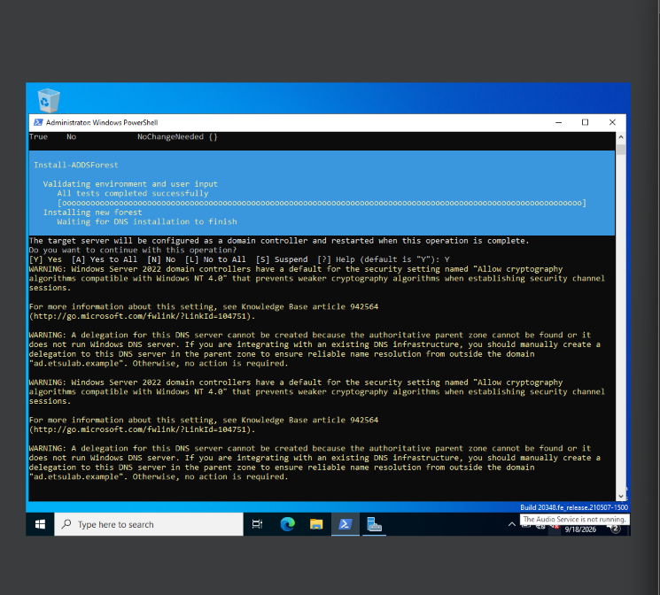
One thing I only noticed afterward: this attempt ended up with the NetBIOS name AD instead of ETSULAB, as the later Get-ADDomain output shows. In attempt 1 and attempt 3 the sign-in prefix is etsulab.

Step 13. Check again after the restart
Same result. whoami shows a domain account, but Get-DnsServerZone lists only the default reverse zones.
A line in my PowerShell window reads Rename-Computer -NewName "SRV-LAB-01" -Restart. Renaming a domain controller after promotion breaks its identity in AD, so that would have been a serious mistake. The later Get-ADDomain output (screenshot 16) still shows DC-LAB-01 as the controller, so the name did not change.
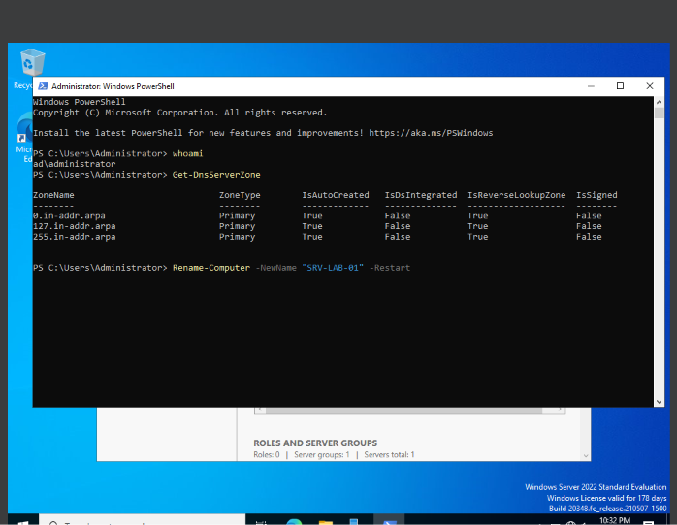
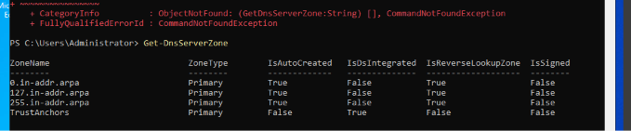

Step 14. Confirm AD itself is healthy
Get-Service ADWS,DNS,DFSR,Kdc,Netlogon
Get-ADDomain
Observed: services running, and Get-ADDomain returns full domain data. Its SubordinateReferences list includes DomainDnsZones and ForestDnsZones, so the DNS partitions exist in the directory. DNS was not serving the zone from them.
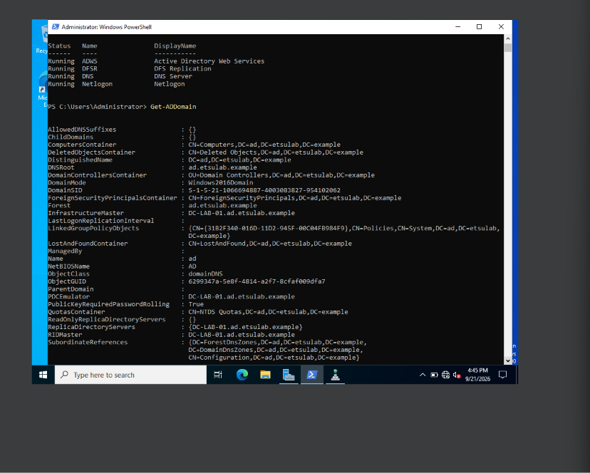
I stopped here for the day and prepared a partial submission, because I could not get past DNS.

5. Attempt 3: the working build (Oct 5)

Step 15. Restore and rebuild
I restored 02-Pre-ADDS again and confirmed the clean state: hostname DC-LAB-01, AD DS, DHCP, and DNS all Available.
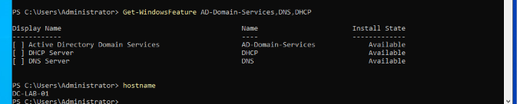
My instructor said a .local suffix would be fine as long as the lab worked. I meant to rebuild as ad.etsulab.local but typed ad.etsu.lab. I noticed after it worked and left it. This means attempt 3 differs from attempts 1 and 2 in two ways at once: the domain name, and my plan to wait longer after the reboot before signing in (I did not time the wait). I can't tell which one mattered. The command below is my reconstruction, since I have no screenshot of the command line itself.
Install-WindowsFeature AD-Domain-Services -IncludeManagementTools
Install-ADDSForest -DomainName "ad.etsu.lab" -DomainNetbiosName "ETSULAB" -InstallDNS -Force

Step 16. Confirm the promotion
Expected: etsulab\administrator, hostname DC-LAB-01. Observed: both. Server Manager in the background shows the new roles.
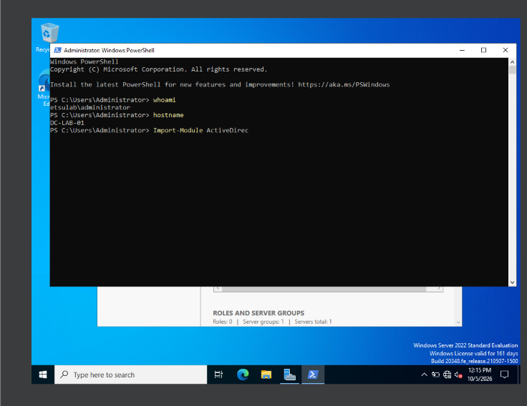

Step 17. Validate DNS
I resolved the domain's records from the DC itself.
Resolve-DnsName -Type SRV _ldap._tcp.dc._msdcs.ad.etsu.lab
Resolve-DnsName 10.20.2.10
Expected: the LDAP SRV record pointing at this DC, and the reverse lookup returning its name. Observed: the SRV record returns dc-lab-01.ad.etsu.lab on port 389 with the A record 10.20.2.10, and the reverse lookup for 10.20.2.10 returns DC-LAB-01.ad.etsu.lab. The red error at the top is my typo (a capital I in _ldap). The correctly typed command succeeded. Since the reverse lookup resolves, I infer a reverse zone for 10.20.2 exists, but I did not capture a screenshot of it.
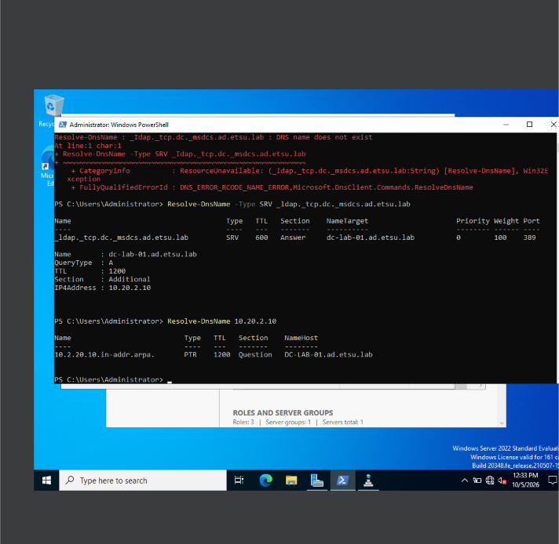

Step 18. Turn on account-management auditing
I did this before creating any accounts so the events would be recorded. In Group Policy Management I created a GPO named DC-Audit-Baseline linked to the Domain Controllers OU, and under Advanced Audit Policy Configuration, Account Management, I enabled Audit User Account Management and Audit Security Group Management for Success and Failure.
Expected: both subcategories show "Success and Failure." Observed: both do.
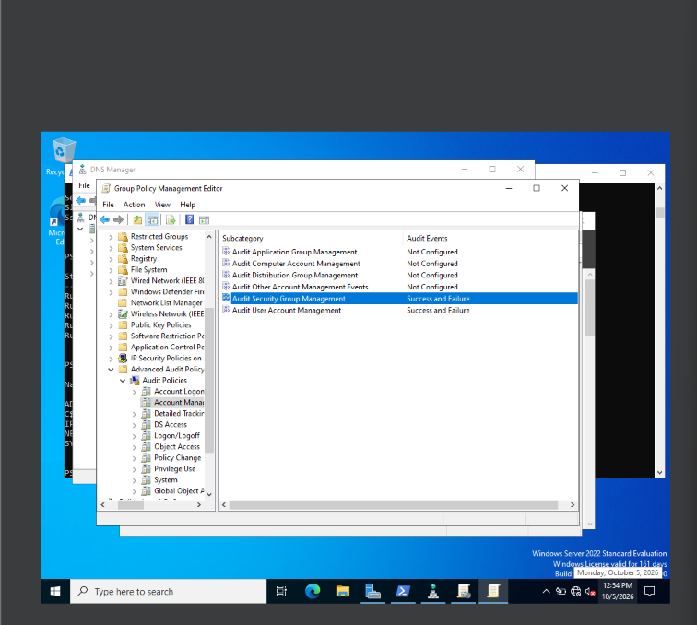

Step 19. Build the OU, user, and group structure
In Active Directory Users and Computers I created three OUs at the domain root (Lab Users, Lab Groups, Lab Computers), a global security group, and a fictional test user ND Student01 in Lab Users, then added the user to the group.
Observed: the three OUs and the user are visible under ad.etsu.lab. The group sits in Lab Groups and isn't shown in this screenshot, so the next step's events are what confirm the membership change.
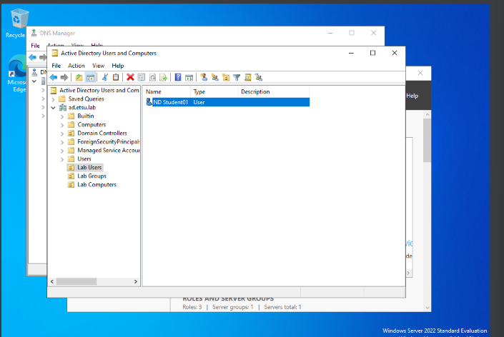

Step 20. Confirm the audit events fired
Get-WinEvent -FilterHashtable @{ LogName='Security'; Id=4720,4728 } -MaxEvents 10 |
Select-Object TimeCreated, Id, Message
My first attempts failed on a syntax error (I left out the ; between hashtable entries). The corrected command returned results.
Expected: 4720 (user account created) and 4728 (member added to a security-enabled global group). Observed: both event IDs, several entries dated 10/5/2026. Two older entries dated 9/17 also appear and I haven't explained them.
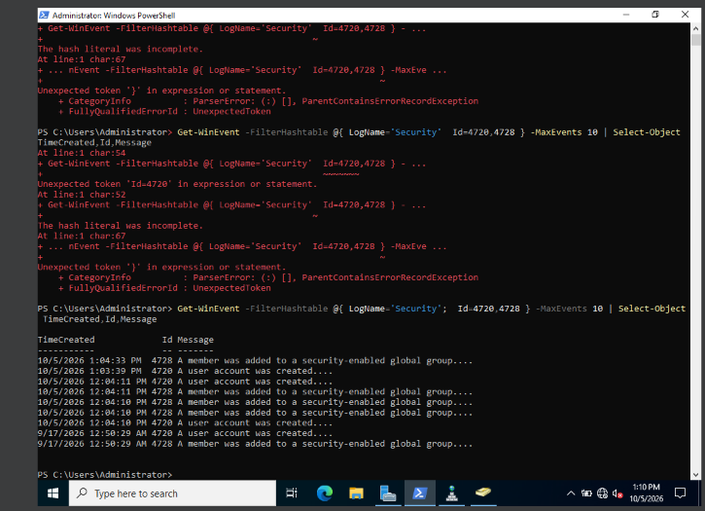

Step 21. Final health check and snapshot
Get-NetFirewallProfile | Select-Object Name, Enabled
Get-MpComputerStatus | Select-Object AntivirusEnabled, RealTimeProtectionEnabled
Get-ADDefaultDomainPasswordPolicy | Select-Object MinPasswordLength, ComplexityEnabled, LockoutThreshold
Get-Service ADWS,DNS,DFSR,KDC,Netlogon
Observed: firewall enabled on Domain, Private, and Public; Defender and real-time protection on; minimum password length 7, complexity on, lockout threshold 0 (the defaults, left unchanged); ADWS, DNS, DFSR, KDC, and Netlogon all running. (I mistyped Get-MpComputerStatus once. The corrected command is below it.)
I then started a snapshot for the finished state, 03-DC-Healthy. The screenshot catches VirtualBox at 47% and the title bar reads "Taking Online Snapshot," meaning the VM was still running instead of cleanly shut down first.
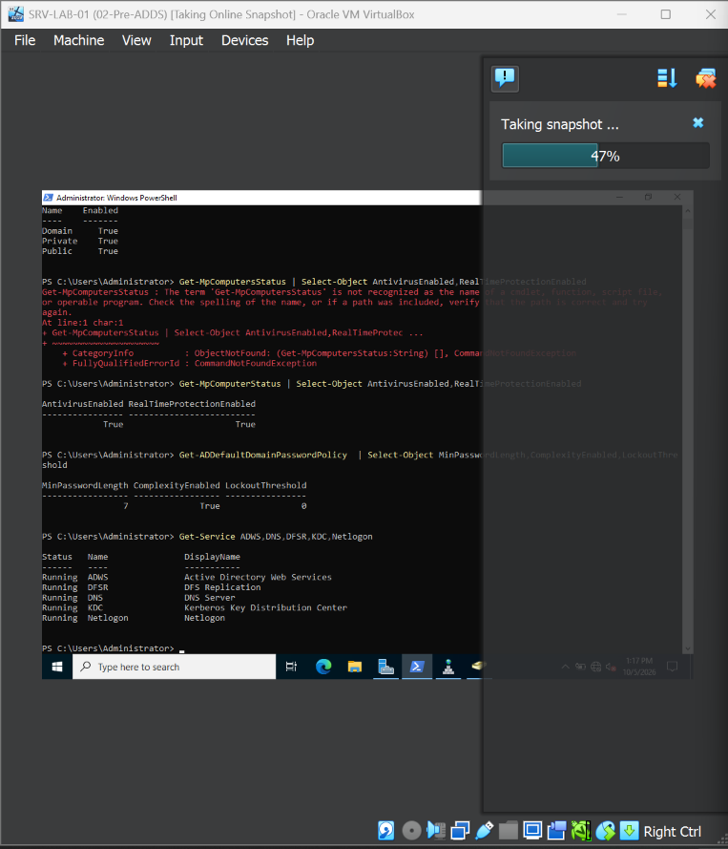

6. What is not covered by my evidence
I'd rather list these than leave them to be discovered:
- The forest name doesn't match the assignment. The spec says ad.etsulab.example. The working build is ad.etsu.lab, a typo of my intended ad.etsulab.local.
- No DNS Manager screenshot of the working build. I confirmed DNS through Resolve-DnsName. I did not capture the zone list, the reverse zone, or the _msdcs zone.
- No dcdiag output for the working build. The only DCDiag screenshot is the failing one from attempt 1.
- The security group isn't visible. The ADUC screenshot shows the OUs and user. The 4728 events indicate group membership changes happened.
- The final snapshot is unconfirmed. I never captured the Snapshots pane showing 01-Baseline-Ready, 02-Pre-ADDS, and 03-DC-Healthy together, and the last snapshot was an online snapshot that I didn't see finish.
- The root cause of the DNS failure is unknown. Events 708 and 4013 suggest DNS started before AD DS was ready. The fix on attempt 3 coincided with a changed name and a longer wait, so I can't credit either.
- I never tried dnscmd /zoneadd. Forcing the zone into existence is something I'd try before restoring a snapshot next time.

7. Command reference
# Networking and identity
Get-NetAdapter | Sort-Object ifIndex | Format-Table ifIndex, Name, Status, MacAddress
Set-DnsClientServerAddress -InterfaceAlias "LAB-LAN" -ServerAddresses 10.20.2.10
Rename-Computer -NewName "DC-LAB-01" -Restart
# Promotion
Install-WindowsFeature AD-Domain-Services -IncludeManagementTools
Install-ADDSForest -DomainName "<domain>" -DomainNetbiosName "ETSULAB" -InstallDNS -Force
# Health and DNS checks
whoami
Get-ADForest | Select-Object Name, ForestMode, RootDomain
Get-ADDomain
Get-DnsServerZone
Get-Service ADWS,DNS,DFSR,Kdc,Netlogon
dcdiag /test:DNS /v
Get-WinEvent -LogName "DNS Server" -MaxEvents 20 | Select-Object TimeCreated, Id, LevelDisplayName, Message | Format-List
Resolve-DnsName -Type SRV _ldap._tcp.dc._msdcs.<domain>
Resolve-DnsName 10.20.2.10
# Audit evidence
auditpol /get /subcategory:"User Account Management"
auditpol /get /subcategory:"Security Group Management"
Get-WinEvent -FilterHashtable @{ LogName='Security'; Id=4720,4728 } -MaxEvents 10 | Select-Object TimeCreated, Id, Message

